Disassembly and Assembly

## Disengagement **Mechanism**

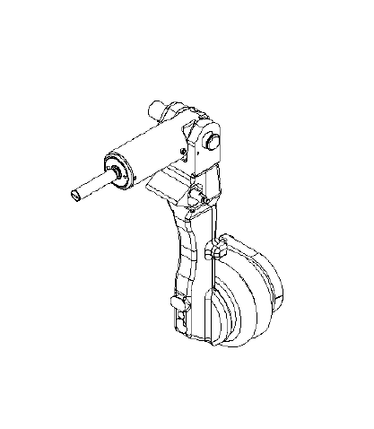

**Original Instructions**

NOT RELEASED 2025-05-09 | No:

Disengagement Mechanism 1

Revision History 3

1. Safety Notes 4

2. Special Tools 4

3. Prerequisites 4

4.1 Labor Resource (People/skills) 4

4.2 Reference Documentation 4

4. Disassembly Procedure 4

5. Assembly Procedure 5

6. Illustration 7

7. Parts List 8

8. Task Specifications 9

# Revision History

|  |  |  |
| --- | --- | --- |
| **Revision No.** | **Date** | **Revision** |
| 001 | August 2025 | Original release |

# 1. Safety Notes

⚠ WARNING: Risk of serious injury if procedure is not performed correctly.

⚠ CAUTION: Risk of equipment damage if the procedure is not performed correctly.

ℹ NOTE: Use the specified tools for correct removal and installation.

# 2. Special Tools

The following tools are required for disassembly and assembly of the disengagement mechanism:

* Torque wrench (1/2-in drive, capacity up to 69 Nm/51 ft-lb)
* Allen key set (M6, M8)
* Open-end spanners (M12, M14)
* Bearing puller

# 3. Prerequisites

Before starting the procedure, ensure the following prerequisites are met:

* Make sure that the system is powered down and isolated from compressed air supply.
* All residual pressure in pneumatic lines is released.
* Work instructions and technical drawings are accessible for reference.

4.1 Labor Resource (People/skills)  
 Service Technician X 1

4.2 Reference Documentation

|  |  |
| --- | --- |
| Manual | Reference |
| Illustrated Parts Catalogue | Model Specific |

# 4. Disassembly Procedure

⚠ WARNING: Risk of serious injury if procedure is not performed correctly.

1. Clean, label, disconnect the pneumatic hoses from the bellows cylinder (Item 7).

ℹ NOTE: Use the specified tools for correct removal.

1. Remove the elbow union (Item 14) from the bellows cylinder (Item 7).
2. Remove the hexagon head bolts (Item 13) that attach the positioning frame (Item 5) to the lever to pneumatic system (Item 1).
3. Remove the positioning frame (Item 5) from the lever to pneumatic system (Item 1).

ℹ NOTE: Use the specified tools for correct removal.

1. Remove the plain bearing with collar (Item 9) that attached to the lever to pneumatic system (Item 1).
2. Support the holder pre-assembled (Item 2) with suitable support equipment.
3. Remove the WSL dynamometer (Item 6) from the lever to pneumatic (Item 1).
4. Remove the holder pre-assembled (Item 2) from the lever of pneumatic system (Item 1).
5. Remove the countersunk screws (Item 12) and O-ring (Item 16) that attach the adapter flange (Item 3) to the bellow cylinder. Discard the hardware.

ℹ NOTE: Use the specified tools for correct removal.

1. Remove the adapter flange (Item 3) from the bellows cylinder (Item 7).
2. Remove the socket head cap screws (Item 17) from the adapter flange. Discard the hardware.
3. Remove the socket head cap screw (Item 11) that attach the bellows cylinder (Item 7) to the lever to pneumatic system. Discard the hardware.

ℹ NOTE: Use the specified tools for correct removal.

1. Slowly remove the bellows cylinder (Item 7) from the lever to pneumatic system (Item 1).
2. Remove the countersunk screw (Item 10) that attach the special bolt (Item 4) to the lever to pneumatic system (Item 1). Discard the hardware.
3. Remove the special bolt (Item 4) from the lever to pneumatic system (Item 1).
4. Inspect all removed components for wear or damage.
5. Store all reusable parts in a clean and safe location.

# 5. Assembly Procedure

1. Replace worn or damaged components with new components.
2. Install the special bolt (Item 4) to the lever to pneumatic system (Item1).
3. Install the countersunk screw (Item 10) to attach the special bolt (Item 4) to the lever to pneumatic system (Item 1).

⚠ CAUTION: Risk of equipment damage if the procedure is not performed correctly.

1. Torque the countersunk screws (Item 10) to 29 Nm (21 ft-lb) dry or lightly oiled, or 26 Nm (19 ft-lb) when using thread lock.

ℹ NOTE: Use the specified tools for correct installation.

1. Install the bellows cylinder (Item 11) in position onto the lever to pneumatic system (Item 1).
2. Install the socket head cap screw (Item 11) that attach the bellows cylinder (Item 7) to the lever to pneumatic system.

⚠ CAUTION: Risk of equipment damage if the procedure is not performed correctly.

1. Torque the socket head cap screw (Item 11) to the 20 Nm (15 ft-lb) dry or lightly oiled, or 19 Nm (14 ft-lb) when using thread lock.

ℹ NOTE: Use the specified tools for correct removal.

1. Install the adapter flange (Item 3) in position onto the bellows cylinder (Item 7).
2. Install the socket head cap screws (Item 17) to the adapter flange (Item 3).

⚠ CAUTION: Risk of equipment damage if the procedure is not performed correctly.

1. Torque the socket head cap screw (Item 17) to the 20 Nm (15 ft-lb) dry or lightly oiled, or 19 Nm (14 ft-lb) when using thread lock.
2. Install the countersunk screws (Item 12) and O-ring (Item 16) to attach the adapter flange (Item 3) to the bellows cylinder.

⚠ CAUTION: Risk of equipment damage if the procedure is not performed correctly.

1. Torque the countersunk screws (Item 12) to 29 Nm (21 ft-lb) dry or lightly oiled, or 26 Nm (19 ft-lb) when using thread lock.
2. Install the holder pre-assembled (Item 2) in position onto the lever of pneumatic system (Item 1).
3. Install the WSL dynamometer (Item 6) from the lever to pneumatic (Item 1).

ℹ NOTE: Lubricate the plain bearing before installing into lever to pneumatic system.

1. Install the plain bearing with collar (Item 9) that attached to the lever to pneumatic system (Item 1).
2. Install the positioning frame (Item 5) in position onto the lever to pneumatic system (Item 1).
3. Install the hexagon head bolts (Item 13) to attach the positioning frame (Item 5) to the lever to pneumatic system (Item 1).

⚠ CAUTION: Risk of equipment damage if the procedure is not performed correctly.

1. Torque the hexagon head bolts (Item 13) to 8.4 Nm (6.2 ft-lb) dry or lightly oiled, or 7.8 Nm (5.8 ft-lb) when using thread lock.

ℹ NOTE: Use the specified tools for correct installation.

1. Install the elbow union (Item 14) from the bellows cylinder (Item 7).

⚠ WARNING: Risk of serious injury if procedure is not performed correctly.

1. Connect the pneumatic hoses to the bellows cylinder (Item 7).
2. Conduct a functional check of the disengagement mechanism.

# 6. Illustration

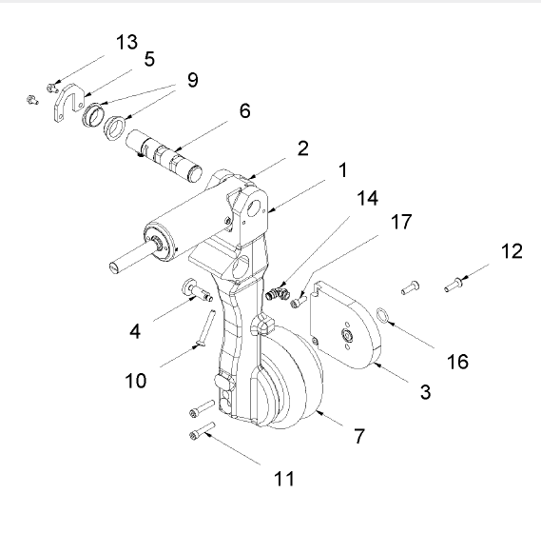

# 7. Parts List

|  |  |  |  |
| --- | --- | --- | --- |
| **Item** | **Part No.** | **Description** | **Quantity** |
| 1 | MRRA-18957-001 | lever to pneumatic system | 1 |
| 2 | MRRA-17659-001 | holder pre-assembled | 1 |
| 3 | MRRA-17643-001 | adapter flange | 1 |
| 4 | MRRA-17637-001 | special bolt | 1 |
| 5 | MRRA-17906-001 | positioning frame | 1 |
| 6 | MRRA-34691-001 | WSL dynamometer | 1 |
| 7 | UNS-23301-009 | bellows cylinder ø165 stroke 125 | 1 |
| 9 | UNN-58004-103 | plain bearing with collar ø30/34x12 | 2 |
| 10 | UNN-10059-098 | countersunk screw | 1 |
| 11 | UNN-10044-065 | socket head cap screw M8x40 basic | 2 |
| 12 | UNN-10060-392 | countersunk screw M8x30 10.9 | 2 |
| 13 | UNN-10015-008 | hexagon head bolt M6x12 galvanized 8.8 | 2 |
| 14 | UNN-24145-048 | elbow union 90° G 1/4" ø8 art. no. 3699 | 1 |
| 16 | UXN-44021-342 | O-ring ø19.2x3.0 FKM 75 Shore A | 1 |
| 17 | UNN-10043-046 | socket head cap screw M8x20 basic | 2 |

# 8. Task Specifications

Use this section to record installation specifications such as torques and pressures.

|  |  |
| --- | --- |
| **Reference Step** | **Assembly Procedure** |
| 4 | Special bolt |
| 7 | Bellows cylinder |
| 10 | Adapter flange |
| 12 |
| 18 | Positioning frame |